1. Sample Dataset (Student Marks)
RegNo | Name | Dept | Marks
101 | Arun | CSE | 78
102 | Bala | IT | 65
103 | Chitra | CSE | 82
104 | Deepa | ECE | 74
105 | Eshan | IT | 90
106 | Farah | CSE | 69
107 | Gokul | ECE | 85
108 | Hari | IT | 73
109 | Isha | CSE | 88

2. Create Dataset in R
RegNo <- c(101,102,103,104,105,106,107,108,109)
Name <- c("Arun","Bala","Chitra","Deepa","Eshan","Farah","Gokul","Hari","Isha")
Dept <- c("CSE","IT","CSE","ECE","IT","CSE","ECE","IT","CSE")
Marks <- c(78,65,82,74,90,69,85,73,88)

student <- data.frame(RegNo,Name,Dept,Marks)

student
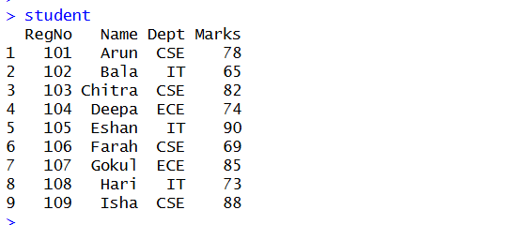

3. Mean, Median, Mode, IQR in R

Mean
mean(student$Marks)
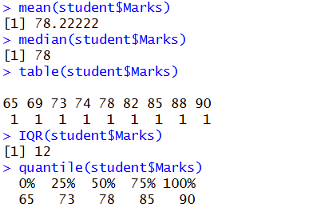

Median
median(student$Marks)

Mode
table(student$Marks)
(No repeated value → No mode)

IQR
IQR(student$Marks)

Quartiles
quantile(student$Marks)

4. Bar Chart (Department wise count)
barplot(table(student$Dept),
col="skyblue",
main="Department Distribution",
xlab="Department",
ylab="Number of Students")
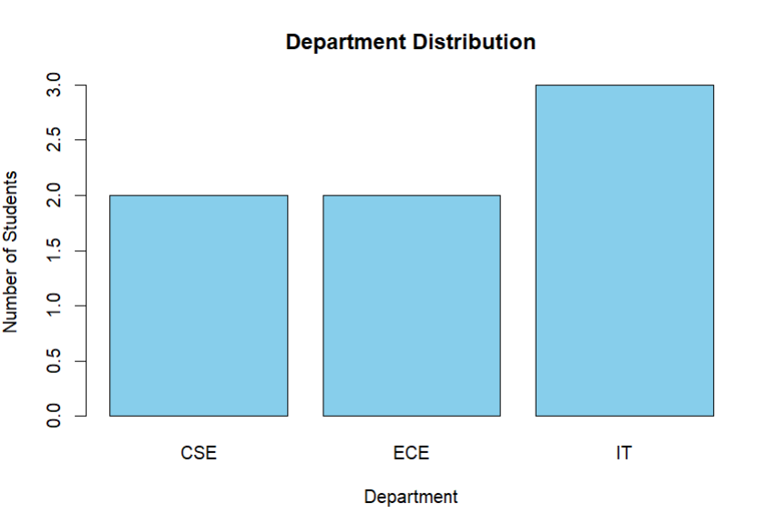

5. Pie Chart
pie(table(student$Dept),
col=c("red","blue","green"),
main="Department Distribution")
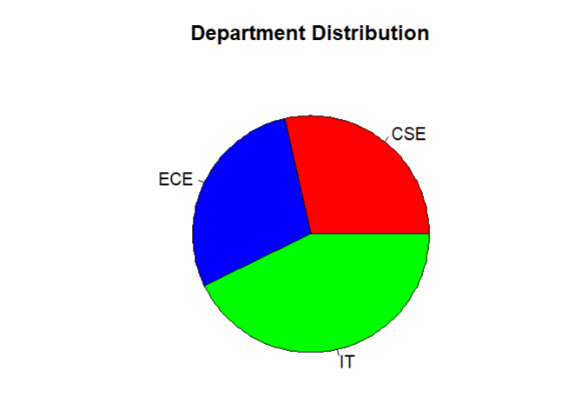

6. Histogram (Marks Distribution)
hist(student$Marks,
col="lightgreen",
main="Histogram of Marks",
xlab="Marks")
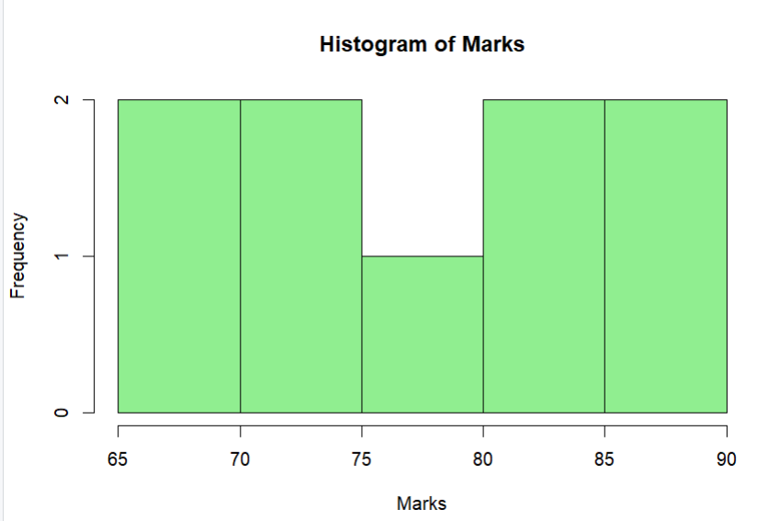

7. Density Plot
plot(density(student$Marks),
col="blue",
main="Density Plot of Marks")
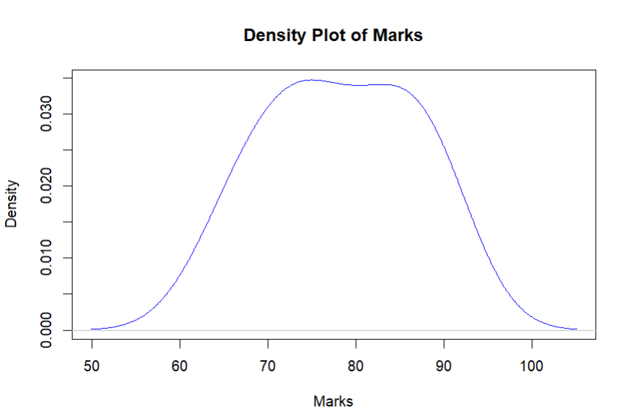

8. Boxplot
boxplot(student$Marks,
col="orange",
main="Boxplot of Marks")
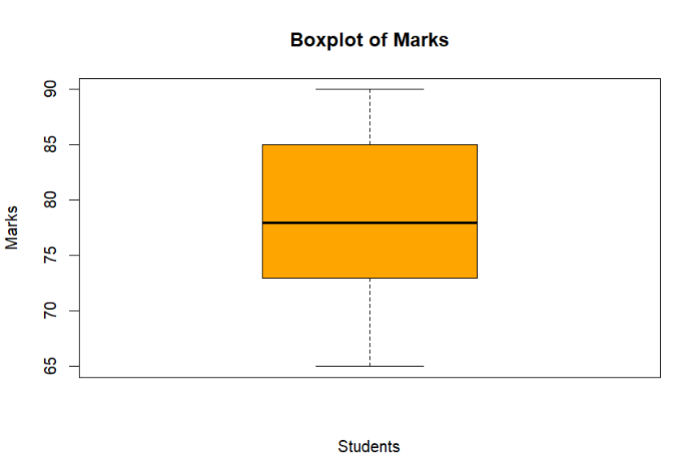

9. Scatter Plot
plot(student$RegNo, student$Marks,
col="red",
pch=19,
main="Scatterplot of RegNo vs Marks",
xlab="Register Number",
ylab="Marks")
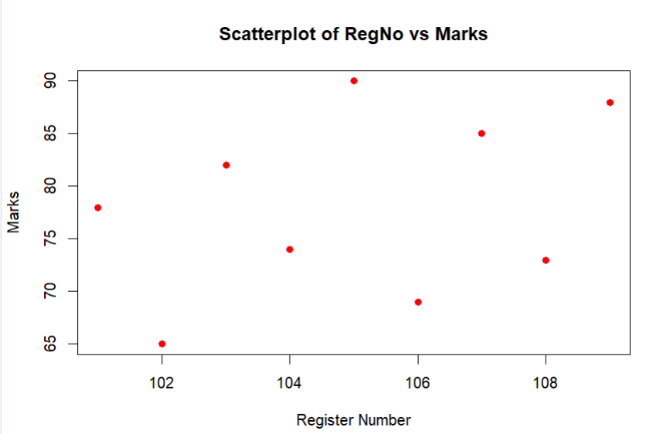

10. Line Chart
plot(student$Marks,
type="l",
col="purple",
main="Line Chart of Marks",
xlab="Student Index",
ylab="Marks")
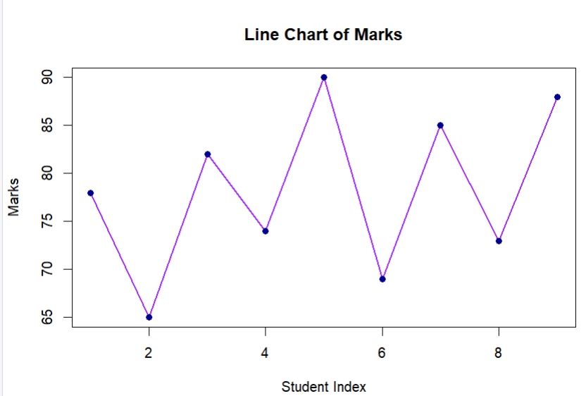

11. Practice Questions (Using Above Data)

(Draw Chart using R)

1. Department Strength Analysis
The college administration wants to see how many students belong to each department to plan classroom allocation.
Question:
Draw a suitable chart in R to show the number of students in each department.
Expected Chart: Bar Chart or Pie Chart
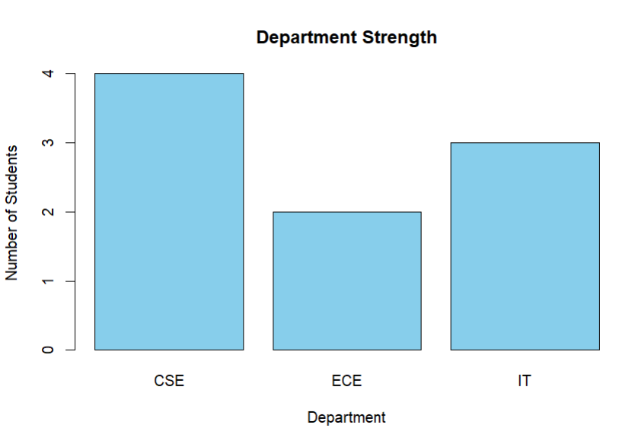

2. Marks Distribution Analysis
The examination committee wants to understand how marks are distributed among students to check whether the exam was easy or difficult.
Question:
Create a chart in R to display the distribution of marks.
Expected Chart: Histogram
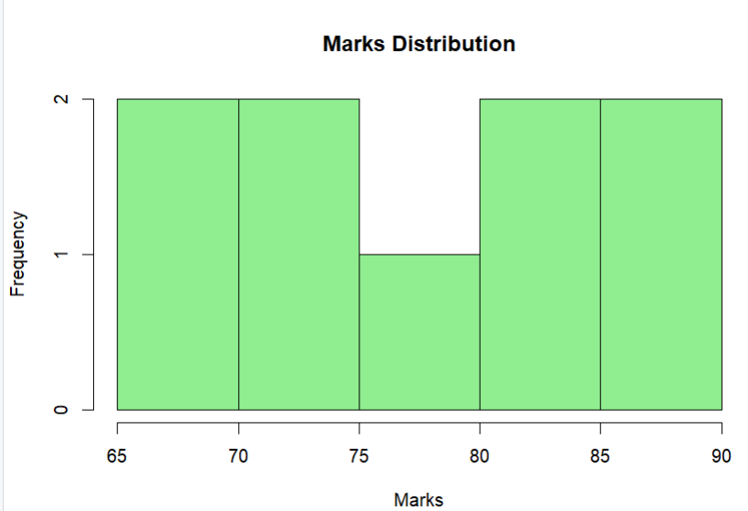

3. Marks Trend Monitoring
A teacher wants to observe how marks vary across student registration numbers to detect performance trends.
Question:
Draw a chart in R showing the trend of marks across students.
Expected Chart: Line Chart
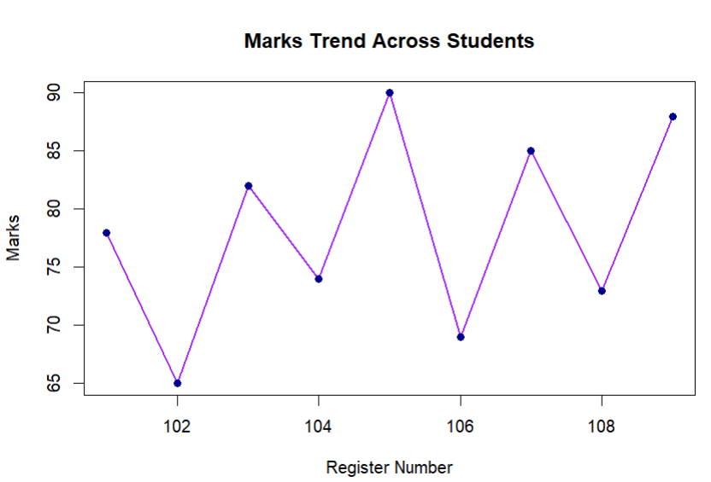

4. Outlier Detection
The academic coordinator wants to identify whether any student marks are unusually high or low compared to others.
Question:
Create a chart in R that helps detect outliers in marks.
Expected Chart: Boxplot
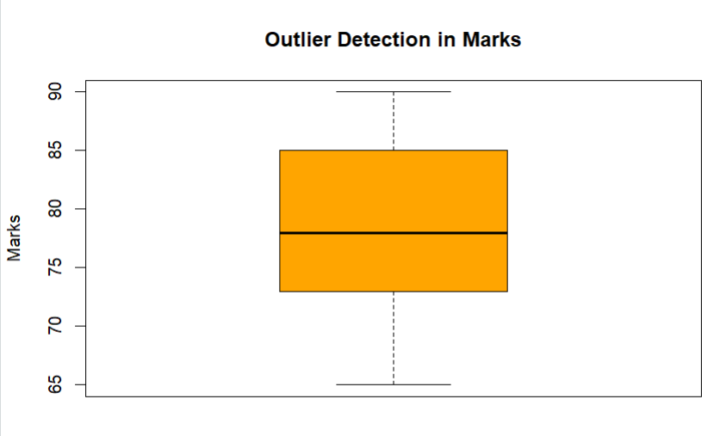

5. Relationship Analysis
The department wants to check if there is any pattern between student registration number and marks scored.
Question:
Plot the relationship between RegNo and Marks using R.
Expected Chart: Scatter Plot
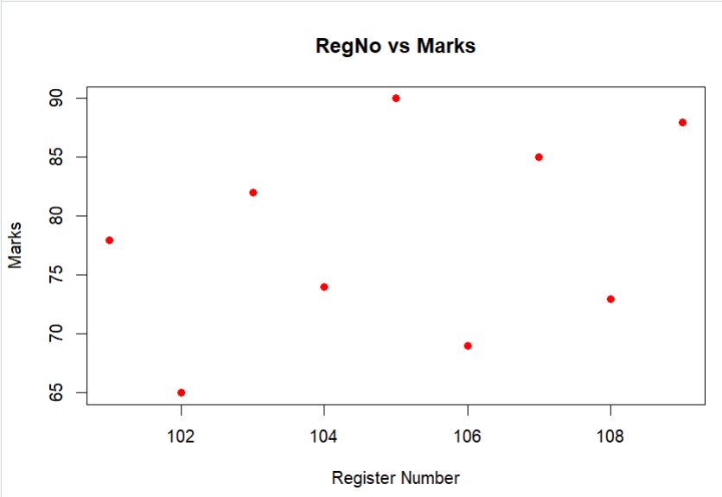

6. Department Percentage Analysis
The management wants to see the percentage contribution of each department in the class.
Question:
Create a chart in R to display the percentage of students in each department.
Expected Chart: Pie Chart
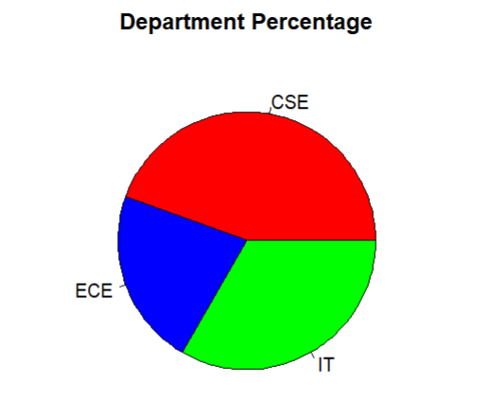

7. Performance Density Study
A data analyst wants to study the smooth distribution pattern of marks to understand the probability of student performance levels.
Question:
Draw a chart in R showing the density distribution of marks.
Expected Chart: Density Plot
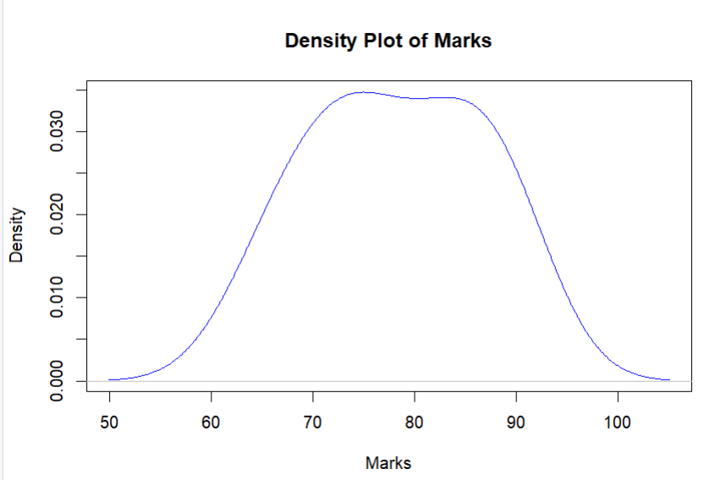

8. Comparative Performance Study
A teacher wants to compare student marks distribution visually to understand overall performance spread.
Question:
Create a suitable visualization in R to summarize the marks distribution using quartiles.
Expected Chart: Boxplot
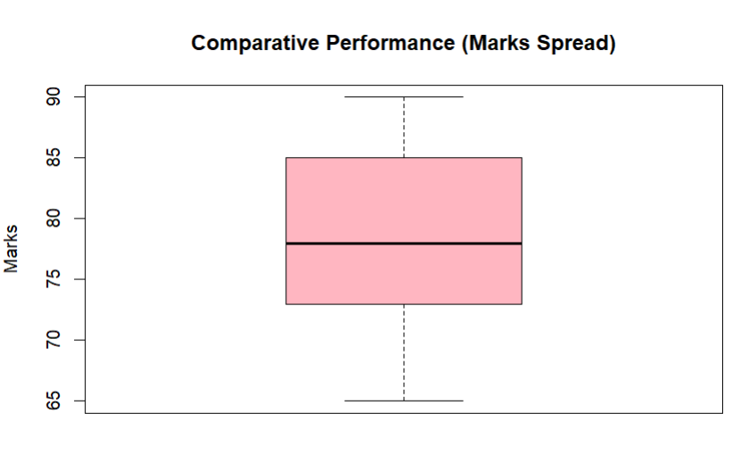

9. Department vs Marks Visualization
The HOD wants to compare marks scored by students across different departments.
Question:
Draw a chart in R that compares marks among departments.
Expected Chart: Boxplot by Department or Bar Chart
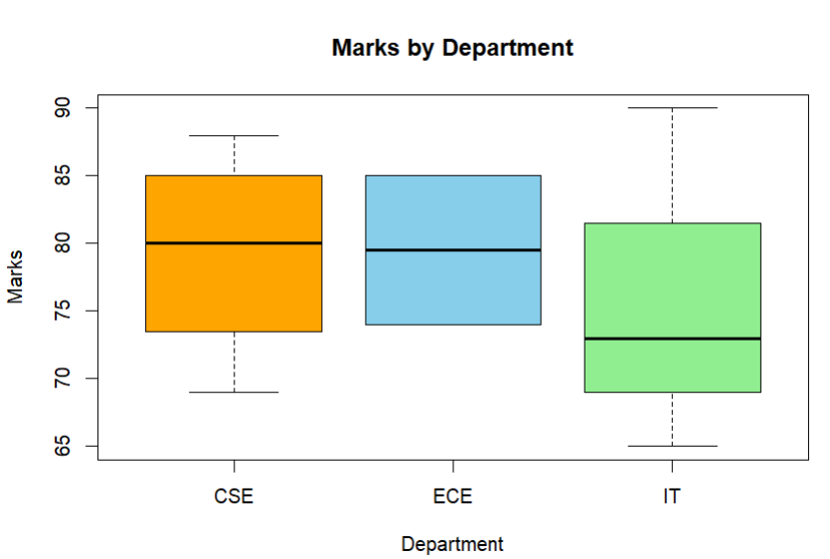

10. Student Performance Overview
The college principal wants a quick visual summary of student marks for a presentation.
Question:
Generate a simple visualization of student marks using R.
Expected Chart: Bar Chart
